The College of Dental Surgeons of Hong Kong | 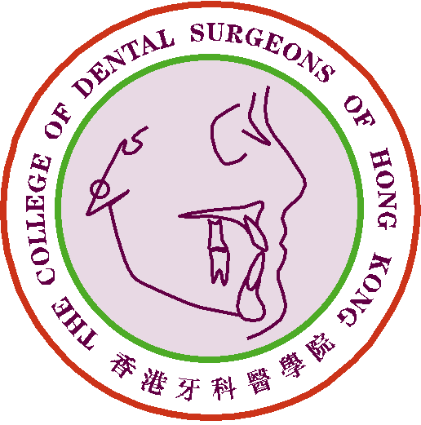

Claim Form for CME/CPD Programme

Personal Data |  | Date of Submission :
Name of Applicant : |  | Phone No.:
Email address: |  | Fax No.:

Please ☑ one only :
1) Fellow or Specialist |  |  | 2) MGD Holder |  |  | 3) Specialist Trainee

<*> must be completed
Publications
Date of Acceptance for Publication (if applicable/known):
*Name of Journal:
*Name of Article:
*Volume of Journal:  (year / volume / page no.) | Year: |  |  | Volume: |  |  |  |  | Page number:
First Author: |  | Co-Author:
Letter of Acceptance: |  | Publication Attached:
No. of CME point(s) claimed:
The Article / Supporting documents attached : |  |  |  |  |  |  |  |  |  |  | page(s):

For Official Use Only | Points Awarded:
For Official Use Only | Total | CME point(s)

- The CME Subcommittee has the rights to evaluate, approve, review and revise the CME point(s) for the above activity/activities.
- Please send this form and other supporting documents by e-mail: cme_cpd@cdshk.org for processing.

(Please make photocopies of these forms whenever applicable or download from
CDSHK website under “Forms Download”: http://www.cdshk.org/Forms/index.htm)

